AWS Task-4

Task Description:

Launch an EC2 instance (Linux and Windows) along with a web server. Then, create an EBS volume of 5 GB, attach it to an EC2 machine (Linux and Windows), and take a snapshot. Finally, create an EBS volume using the taken snapshot.

Techstacks needs to be used :

- AWS EBS
- AWS EC2

How do I submit my work?

- Push all your work files to GitHub (O/P screenshot images must).
- Submit your URLs in the portal.

Terms and Conditions?
- You agree to not share this confidential document with anyone.
- You agree to open-source your code (it may even look good on your profile!). Do not mention our company’s name anywhere in the code.
- We will never use your source code under any circumstances for any commercial purposes; this is just a basic assessment task.
NOTE: Any violation of Terms and conditions is strictly prohibited. You are bound to adhere to it.
1. Launching EC2 Instances
Explanation:
Two EC2 instances were launched:
- A Linux EC2 (Amazon Linux 2) for hosting Apache web server.
- A Windows EC2 (Windows Server 2022) for hosting IIS web server.
Security groups were configured to allow HTTP, SSH (Linux), and RDP (Windows) access.

Screenshot:
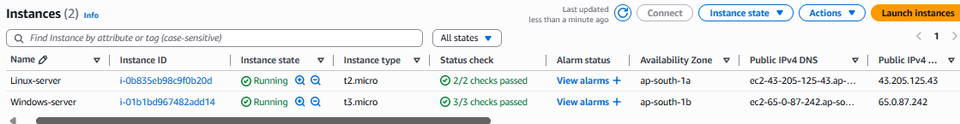

2. Configuring Web Server on Linux
Explanation:
On the Linux EC2 instance, Apache (httpd) was installed and configured. A test HTML page was created to verify the setup.

Screenshot:
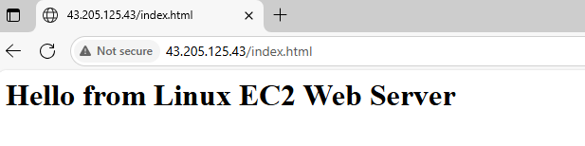

3. Configuring Web Server on Windows
Explanation:
On the Windows EC2 instance, IIS was installed using Server Manager. A test HTML page was placed inside C:\inetpub\wwwroot\ to confirm the setup.
Screenshot: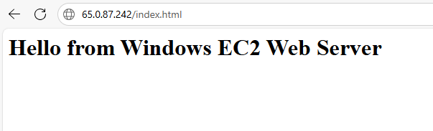

Root volumes of Linux & Windows server

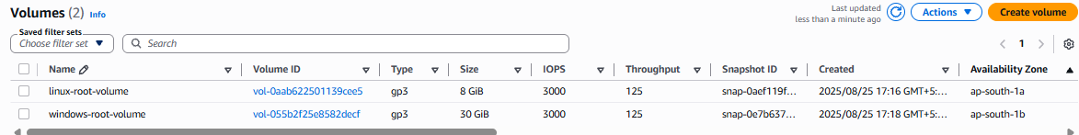

4. Creating and Attaching EBS Volumes
Explanation:
A 5 GB EBS volume was created for each instance (Linux and Windows). Volumes were attached to their respective instances in the same Availability Zone.

Linux

Windows

Data volume attached for Linux server

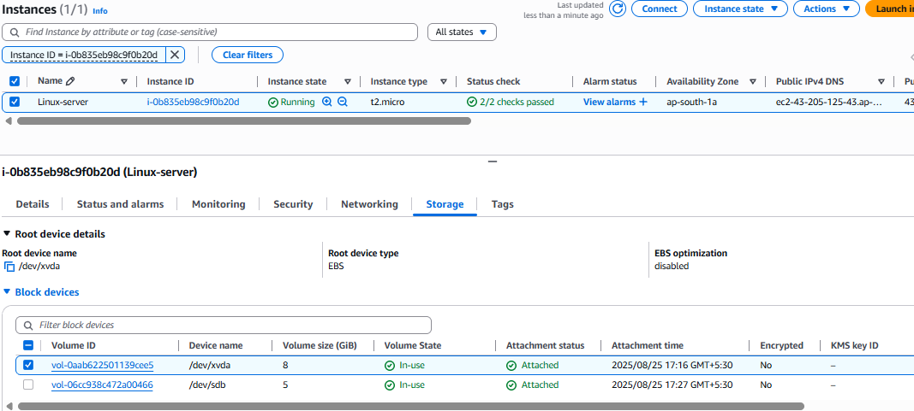

Data volume attached for Windows server
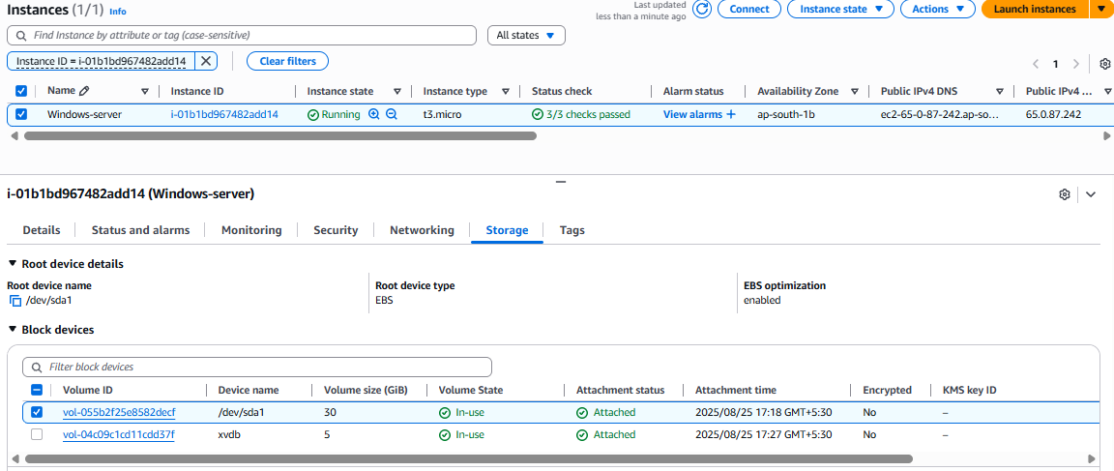
5. Mounting and Formatting EBS Volume on Linux
Explanation:
The attached Linux volume /dev/xvdb was formatted with XFS filesystem and mounted on /data_volume.
Screenshot:

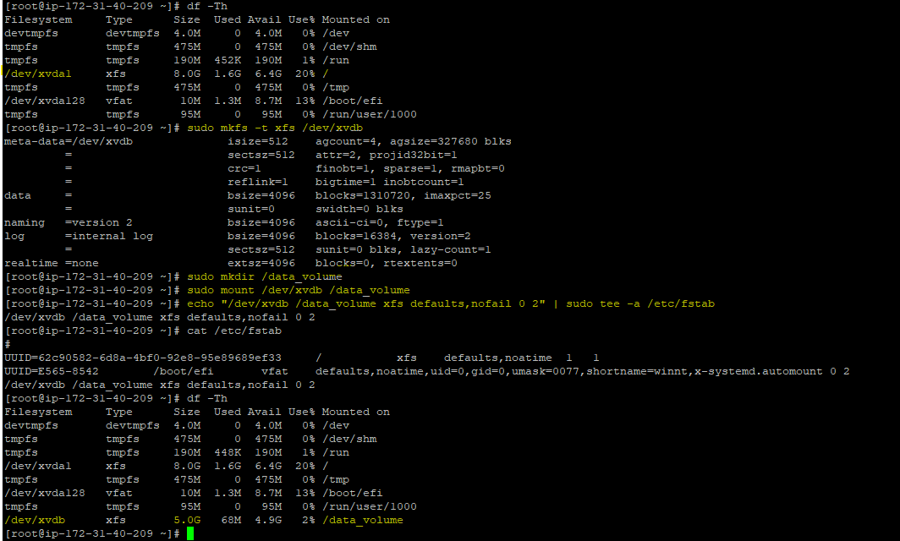
Mounting and Formatting EBS Volume on Windows
Explanation:
On the Windows EC2 instance, diskmgmt.msc was used to initialize and format the attached disk. The disk was assigned drive letter D: and formatted with NTFS.

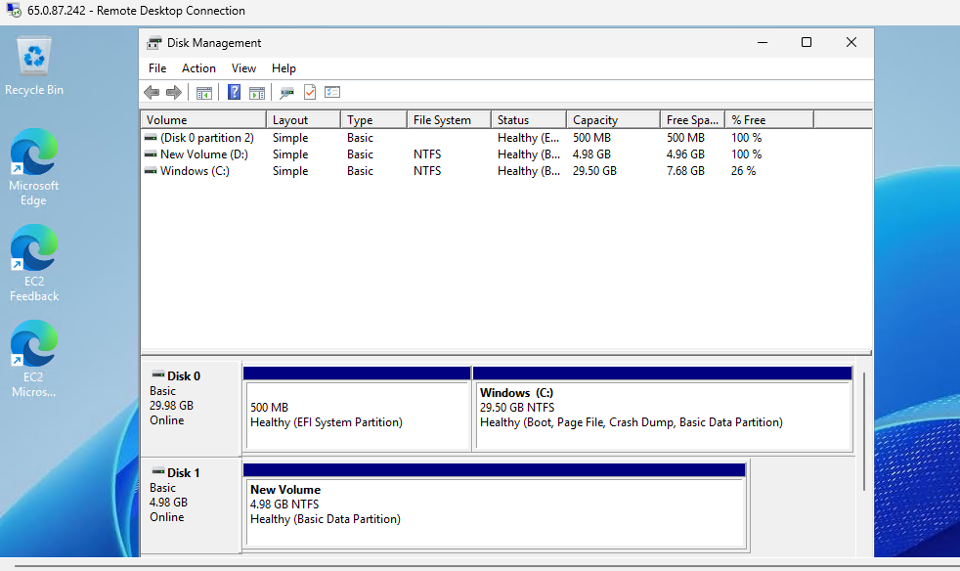

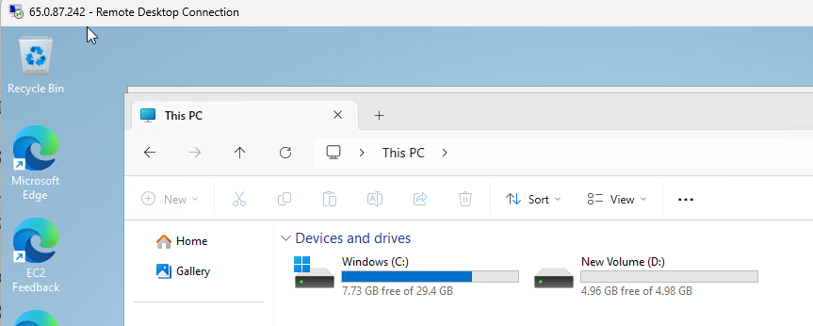
7. Creating Snapshots
Explanation:
Snapshots were created for both Linux and Windows EBS volumes from the AWS Management Console. These snapshots serve as backups of the volumes.
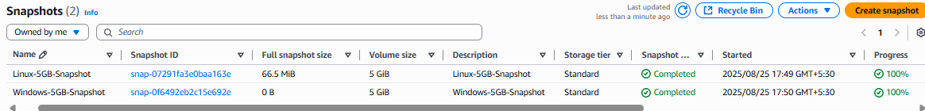

7. Creating volumes from the snapshot
I know how to create volumes from these snapshots
Select the snapshot - > Actions -> Create volume.
I have also created the volumes from the above-mentioned snapshots.
But before taking screenshot the Aws lab suddenly disconnected and it shows Deleted.

